Chapter 16, Problem 86.

Develop the state equations for Problem 16.12.

Chapter 16, Problem 12.

Determine i(t) in the circuit of Fig. 16.35 by means of the Laplace transform.
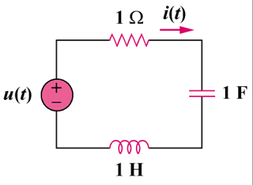
u(t)V

Figure 16.35
For Prob. 16.12.

